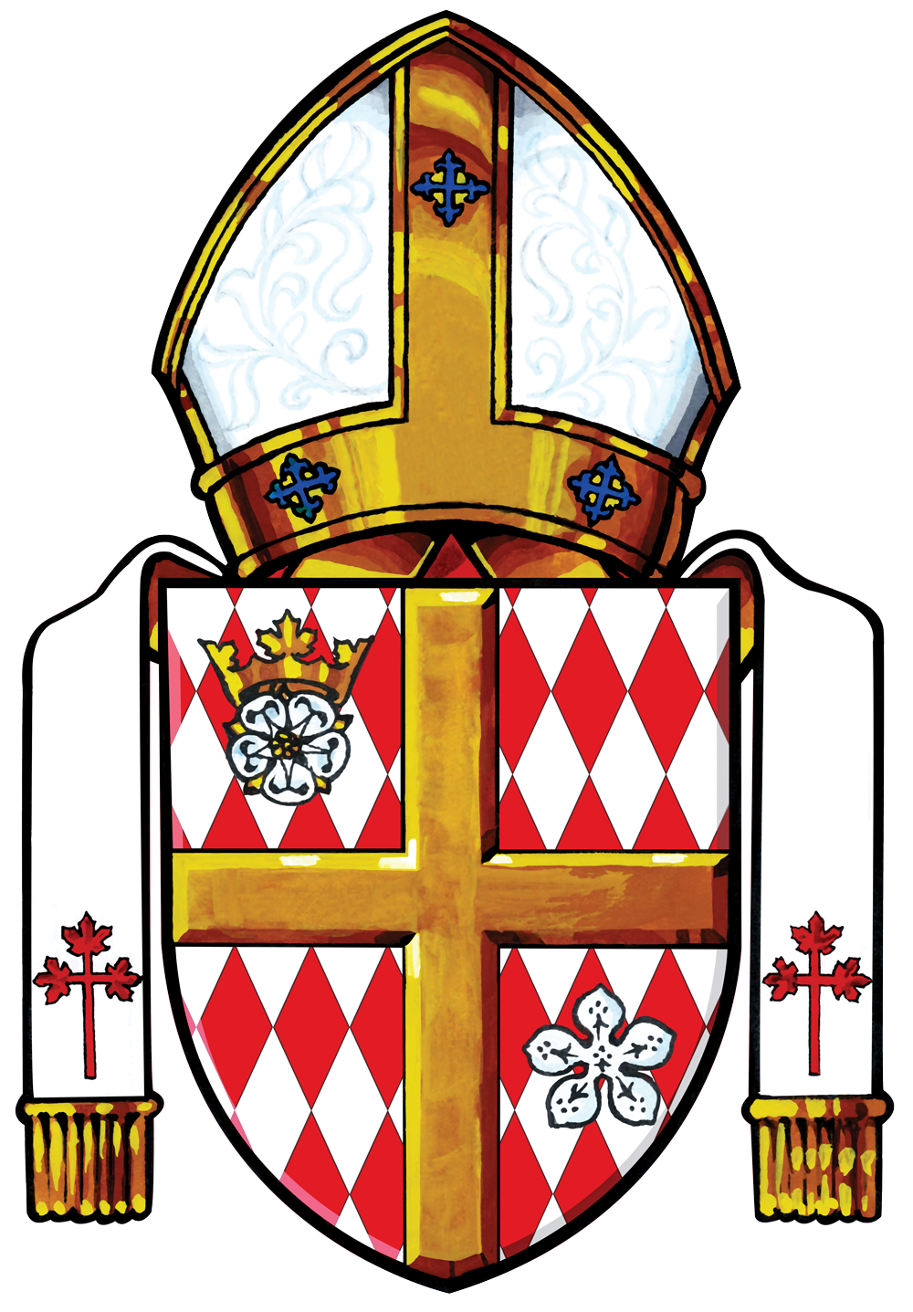

Holy Hour
Prayer For Survivors And Victims
of Sexual Abuse

Second Sunday of Lent

Exposition of the Blessed Sacrament

When all have assembled, the presiding priest (or deacon) approaches the altar, reverences it, and proceeds to the tabernacle to bring the Blessed Sacrament to the altar, to be placed in the monstrance. When the Blessed Sacrament has been placed in the monstrance, the presiding minister, after putting incense in the censor, kneels and incenses the Holy Eucharist.

During this time a suitable song is sung by the assembly, who remain standing.

Some suitable songs include:

Healer of Our Every Ill (CBW III – 363)
All You Who Seek a Comfort Sure (CBW III – 425)
Great God of Mercy (CBW III -361)
Shelter Me, O God (CBW III – 372)
Eye Has Not Seen (CBW III – 482) (G&P 645)

Greeting

The presiding minister greets the people, saying:

Praised be the God and Father of our Lord Jesus Christ,
who has bestowed on us in Christ every spiritual blessing in the heavens.
Blessed be God for ever.

All:

Blessed be God for ever.

Opening Prayer

The presiding minister invites the people to pray using these or similar words:

Let us pray today for all victims of sexual abuse,
that they may receive healing from the Lord
and experience the compassionate love of God
through our prayers for them today.

After a brief pause for silent prayer, the presiding minister continues:

God of tender mercy and compassion,
who extend your healing hand to your children,
look with mercy on those who have been sexually abused,
and who carry the painful memories of trust betrayed.
Restore them to health and renew within them
a deep awareness of your steadfast love for them.

Draw to yourself all those who have been alienated
from the community of the Church
because of the sins of its members.
Reconcile them to the Body of your Son, Jesus Christ,
and fill their hearts with enduring peace.

May your Holy Spirit direct our steps
to bring an end to every form of violence and abuse
and to create safe places for every person,
especially our vulnerable children.

We ask this through our Lord Jesus Christ, your Son,
who lives and reigns with you, in the unity of the Holy Spirit,
one God, for ever and ever.

All:

Amen.

Liturgy of the Word

All are seated for the Liturgy of the Word. One of the following readings may be proclaimed.

Romans 8.26-27

A reading from the Letter of Saint Paul to the Romans

Brothers and sisters:
The Spirit helps us in our weakness;
for we do not know how to pray as we ought,
but that very Spirit intercedes with sighs too deep for words.
And God, who searches the heart,
knows what is the mind of the Spirit,
because the Spirit intercedes for the saints
according to the will of God.

The word of the Lord.
R. Thanks be to God.

OR

1 Peter 5:5b, 7, 10b-11

A reading from the First Letter of Saint Peter.

Brothers and sisters:
Clothe yourselves with humility in your dealings with one another,
For God opposes the proud, but gives grace to the humble.
Cast all your anxiety on him, because he cares for you.
The God of all grace,
who has called you to his eternal glory in Christ,
will himself restore, support, strengthen, and establish you.
To him be the power for ever and ever. Amen.

The word of the Lord.
R. Thanks be to God.

A period of silence follows the reading.

Responsorial Psalm

One of the following psalms may be used.

Psalm 341-2, 16-17, 18 +22

R. The poor one called and the Lord heard.

See Sunday Lectionary, page 752
Catholic Book of Worship III, # 201

OR

Psalm 69.7-9, 13+16, 32-33,35ab +36

R. Lord, in your steadfast love, answer me.

See Sunday Lectionary, page 473
Catholic Book of Worship III, #145

OR

Psalm 27. 1, 7-8,9, 13-14

R. The Lord is my light and my salvation.

See Sunday Lectionary, page 210
Catholic Book of Worship III, # 49

Gospel Acclamation

All stand for the Gospel Acclamation. A familiar setting of the Lenten Acclamation is sung. The following verse may be used:

Trust in God and trust in me,
says the Lord.

Gospel Proclamation

One of the following Gospel passages may be proclaimed.

Matthew 11.28-30

A reading from the holy Gospel according to Matthew.

At that time Jesus said:
“Come to me,
all you that are weary and are carrying heavy burdens,
and I will give you rest.
Take my yoke upon you, and learn from me;
for I am gentle and humble in heart,
and you will find rest for your souls.
For my yoke is easy, and my burden is light.”

The Gospel of the Lord.
R. Praise to you, Lord Jesus Christ.

OR

Matthew 18.5-7, 10

A reading from the holy Gospel according to Matthew.

Jesus said to his disciples:
“Whoever welcomes one such child in my name welcomes me.
If any of you put a stumbling-block before one of these little ones who believe in me,
it would be better for you
if a great millstone were fastened around your neck
and you were drowned in the depth of the sea.
Woe to the world because of stumbling-blocks!
Occasions for stumbling are bound to come,
but woe to the one by whom the stumbling-block comes!
Take care that you do not despise one of these little ones;
for, I tell you, in heaven their angels continually see
the face of my Father in heaven.

The Gospel of the Lord.
R. Praise to you, Lord Jesus Christ.

OR

Mark 4.25-41

A reading from the holy Gospel according to Mark.

On that day, when evening had come, Jesus said to his disciples,
‘Let us go across to the other side.’
And leaving the crowd behind,
they took him with them in the boat, just as he was.
Other boats were with him.
A great gale arose, and the waves beat into the boat,
so that the boat was already being swamped.
But he was in the stern, asleep on the cushion;
and they woke him up and said to him,
‘Teacher, do you not care that we are perishing?’
He woke up and rebuked the wind, and said to the sea,
‘Peace! Be still!’
Then the wind ceased, and there was a dead calm.
He said to them, ‘Why are you afraid? Have you still no faith?’
And they were filled with great awe and said to one another,
‘Who then is this, that even the wind and the sea obey him?’

The Gospel of the Lord.
R. Praise to you, Lord Jesus Christ.

OR

John 10.11-18

A reading from the holy Gospel according to John.

Jesus said:
‘I am the good shepherd.
The good shepherd lays down his life for the sheep.
The hired hand, who is not the shepherd and does not own the sheep, sees the wolf coming and leaves the sheep and runs away
—and the wolf snatches them and scatters them.
The hired hand runs away
because a hired hand does not care for the sheep.
I am the good shepherd.
I know my own and my own know me,
just as the Father knows me and I know the Father.
And I lay down my life for the sheep.

The Gospel of the Lord.
R. Praise to you, Lord Jesus Christ.

A brief homily may be given. A homily or reflection may include some of the insights from Protecting Minors from Sexual Abuse (CCCB, 2018) pages 53-57.

Spiritual Healing
Forgiveness and Healing
Community Support and Healing.

SILENT PRAYER

Following the homily or reflection an extended period of silence is observed for private prayer.

Intercessory Prayer

At the conclusion of the period of silent prayer, one of the following prayers may be offered.

A. Prayer for those Abused

All say together.

Praise to you, Father of Our Lord Jesus Christ,
source of all consolation and hope.
By your Son’s dying and rising
he remains our light in every darkness,
our strength in every weakness.
Be the refuge and guardian
of all who suffer from abuse and violence.
Comfort them and send them healing
for their wounds of body, mind and spirit.
Rescue them from bitterness and shame
and refresh them with your love.
Heal the brokenness in all victims of abuse
and revive the spirits of all who lament this sin.
Help us to follow Jesus
in drawing good from evil, life from death.
Make us one with you in your love for justice
as we deepen our respect
for the dignity of every human life.
Giver of peace, make us one in celebrating your praise,
both now and forever . Amen.

(United States Catholic Conference of Bishops)

OR

B. Litany

The presider begins.

As the Risen Lord accompanied his disheartened disciples on the road to Emmaus, so he accompanies us in this time of pain and sorrow for the victims of sexual abuse and for our entire community. We ask that the Lord to “stay with us”.

The Litany continues, with the people responding:

When surrounded by darkness Stay with us, Lord.
When trust is betrayed Stay with us, Lord
When promises are broken Stay with us, Lord.
When acts of violence occur Stay with us, Lord.
When we are paralysed by fear Stay with us, Lord.
When burdens feel too heavy Stay with us, Lord.
When we cannot see you Stay with us, Lord.
When forgiveness is difficult Stay with us, Lord.
When healing is slow Stay with us, Lord.
When faith is challenged Stay with us, Lord.
When hope seems faint Stay with us, Lord.

The presider continues:

We ask the Risen Lord to continue to walk with and protect those who are burdened. We ask the Lord to “walk with them”.

The Litany continues, with the people responding:

For all who suffer Walk with them, Lord.
For all who are sick and in pain Walk with them, Lord.
For all who are struggling Walk with them, Lord.
For all who have been abused Walk with them, Lord.
For all who have lost hope Walk with them, Lord.
For all who are grieving Walk with them, Lord.
For all who are depressed Walk with them, Lord.
For all who feel rejected Walk with them, Lord.
For all who feel unloved Walk with them, Lord.
For all who are oppressed Walk with them, Lord.
For all who are disheartened Walk with them, Lord.

The Litany concludes:

Lord, have mercy. Lord, have mercy.
Christ, have mercy. Christ have mercy.
Lord, have mercy. Lord, have mercy.

OR

C. Intercessory Prayer

The presider begins:

We turn to God in sorrow and humility, asking for the graces of mercy, healing and forgiveness. We pray: Lord, hear our prayer.

A minister announces the intercessions.

Let us pray for forgiveness for the crimes and sins of sexual and physical abuse perpetrated by clergy and servants of the Church against children and young people. (silent prayer)

God of compassion and love, we ask forgiveness for the failure to love, respect, nurture and cherish young people, especially the most vulnerable. (R)

Let us pray for the survivors of abuse who have been psychologically harmed and spiritually damaged by people claiming to be followers of your Son. (silent prayer)

God of compassion and love, we pray for healing and peace for all those who have been abused and whose suffering continues. (R)

Let us pray for forgiveness for all those in authority in the Church who failed to respond as good shepherds to those abused by priests and religious. (silent prayer)

God of compassion and love, we ask your forgiveness for those in leadership whose ears have been deaf, whose eyes have been blind, and whose hearts have been hardened to the cry of your abused children. (R)

Let us pray for the families and friends of those who have been abused as we lament the pain and sorrow they carry because of the injuries inflicted upon their loved ones. (silent prayer)

God of compassion and love, we ask you to heal the families and friends of those who have been abused. In your love, protect and comfort them. (R)

The presider concludes:

God of compassion and love, hear the prayers of your faithful people.
In your mercy, grant us what we ask in faith
through Christ our Lord.

All respond:

Amen.

Benediction & Reposition
of the Blessed Sacrament

The priest or deacon approaches the altar, genuflect before the Blessed Sacrament, and incenses the Sacrament. During the incensation, all may sing a Eucharistic hymn, such as one of the following:

Come Adore / Tantum Ergo (CBW III – 688)
O Saving Victim / O Salutaris (CBW III – 689)

Then, the priest or deacon stands and says:

Let us pray.

After a brief pause for silent prayer, he continues:

Lord our God,
you have given us the true bread from heaven.
In the strength of this food
may we live always by your life
and rise in glory on the last day.

We ask this through Christ our Lord.

All:

Amen.

Eucharistic Blessing

The presiding priest or deacon, wearing the humeral veil, may then give the Eucharistic blessing. He first genuflects, then takes the monstrance and makes the sign of the cross with it over the people in silence.

Then the priest or deacon removes the Blessed Sacrament from the monstrance and places it in the tabernacle. He genuflects and returns to the chair for the dismissal.

Dismissal

The presiding minister dismisses the people using the following words:

Go forth in peace to proclaim God’s saving love for all.

The people respond:

Thanks be to God.

The Holy Hour may conclude with a hymn or in silence. During Lent it is not fitting to conclude with instrumental music.

